Dessa shapiro

9/9/18

Period 4 and 6

My Identity as a Reader

I have been reading since my earliest memory, which was when I was around 4 years old. I first learned to read with my parents, like most children my parents read to me every night before bed. I think that's when I got my start and how I was taught to read. The very first book that I remember is “The Fire Cat” my dad used to read this book to me, It was about a can who lived with firemen but never felt like he fit in. The first teacher that helped me learn to read was Mrs. Luck, my 2nd-grade teacher. I remember her telling us her life story and how she was forced to flee her homeland when she was only 12 years old. When I first learned to read I found it hard to read more complicated words. Over time I got more comfortable with sounding words out and that made reading easier. The first time I read a book on my own was when I was in kindergarten. When I was younger I didn't enjoy reading that much because I thought it was hard, but as I got older I became more comfortable with words. As I started to understand the meaning of more words I started to enjoy reading because I could focus on the story, not the words.

One of my overall favorite books is Counting by 7’s, I loved this book because I felt that I was in the story. Throughout school, I have had to read a lot of books. In elementary school I never liked the books we read in class, I almost always found them boring. The first time I enjoyed reading a book in school was in 7th grade when our class read the outsiders. From that point on I have liked most of the books I’ve read in school. My favorite genre is fiction, and from there I like a lot of different types of fiction stories, I read fantasy, horror, mystery, action, drama, sci-fi, and some romance. I like reading a lot of different genres because I like experiencing all the different worlds and experiences that come with each of them. I see reading as a way to leave your reality behind and lose yourself in a different world for a while. My main goal is to learn how to disgust for dense books and to learn how to pull important information out of a book while working on a project.

List of books from the last 3 years

* Cinder
* Scarlet
* Counting by 7s
* Marley and me
* Amulet saga(7 books)
* Twilight saga(4 books)
* Dorothy Must Die saga(7 books)
* Me and Earl and the Dying Girl
* Flawed
* El deafo
* Pegasus(the flame of olympus)
* Pegasus(olympus at war)
* Throne of Glass saga(5 books)
* 11 birthdays
* Divergent
* The Sun is also a Star
* Extras
* The Outsiders
* To kill a Mockingbird
* Matched saga(3 books)
* The fault in our stars
* Everything everything
* Selection saga(5 books)
* The Siren
* Hatchet
* Maximum ride saga(8 books)
* The Lightning Thief
* The Sea of Monsters
* The Titan’s Curse
* The Battle of the Labyrinth
* The Last Olympian
* The Lost Hero
* The Son of Neptune
* The Mark of Athena
* The House of Hades
* The Blood of Olympus
* The Red Pyramid
* The Sword of Summer
* Yona of the dawn manga(19 volumes)
* Harry Potter saga(7 books)
* Red Queen
* Glass Sword
* The hunger games saga(4)

Dessa Shapiro

Period 4 & 6

My first Connection

I am reading the book “*I Am Malala”* by Malala Yousafzal. This book is about Malala's life as a young girl in Swat, Pakistan. The book talks about the experiences that Malala had to suffer through when The Taliban(A radically militant Islamic movement)took control of Swat(a district in Malakand Division of Khyber Pakhtunkhwa province in Pakistan.) The Taliban came into Malala's life when she was around 10 years old. They started as a small organisation on the radio but rapidly grew. They started to become violent, and make insane rules. They banned girls from going to school and leaving their houses. They also banned technology and told people what jobs they could do and what jobs they couldn't. Malala’s father owned a school, so he believed that everyone had the right to an education. Malala grew up with the influence of her father's beliefs, later in life she took a lot of those beliefs with her.

Malala started talking out at events and important political meetings. One of these events was an interview and Malala stated “ ‘they cannot stop me. I will get my education if it’s at home,school or somewhere else. This is our request to the world - to save our schools, save our Pakistan,save our Swat.’ ” ( Pg. 161)

I feel that I can relate to this passage because I know that when I really love something I will always do anything to that thing no matter the risks. What Malala talks about is much more extreme because the thing that she loved was banned and it because dangerous to do that thing. Where I am from, there is no danger of the things I love being taken from me. I can still relate to Malala because I can imagine someone taking what I love away and I know that would be unbearable. When I was in 3rd grade my family decided to move to California. We wanted to look at possible areas to live in before we fully committed and moved. My whole family went to California together at first but there was too much ground to cover. So, my dad decided to go off on his own and look for places. I was young when he left and it was very hard for me. He had always been very close but now I would only see glimpses of him. I thought I had lost him. I think that you could apply this to what Malala is saying about thinking she lost the thing she loves.. I can better relate to the passage when I picture losing my family. I think I can relate this to my family more because I’m not particularly passionate about one certain thing, as Malala is about women's education. Overall Malala’s life is very different than mine and I hopefully won't ever experience what she had to go through. And I will never be able to totally empathize with her, but some aspects of our lives are similar.

**Song: Far away by carole king**

This song is about being away from the person you love.

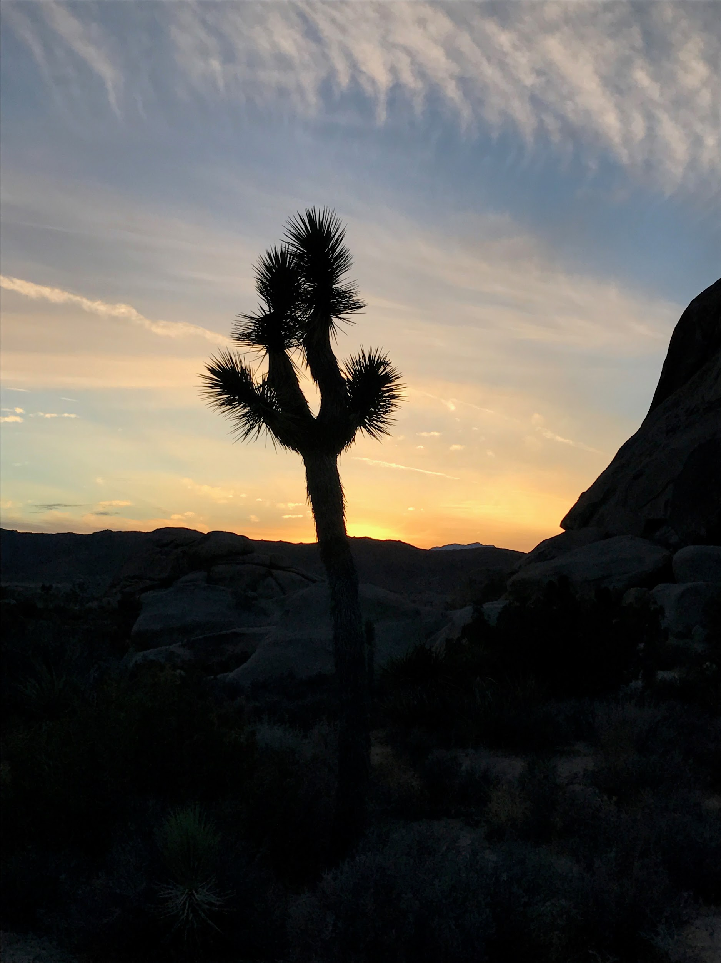

This one of the places me and my family visited when my dad was getting our belongings back in Colorado.

Dessa Shapiro

9/27/19

School Life

Over the past week or so I have gotten farther into the book “I Am Malala” by Malala Yousafzai. In the first blog entry, I explained how the Taliban came into Malala’s life and about her early childhood. As I’ve gotten farther into the book a lot of new developments have occurred in Malala’s life. She is still a young girl but is now around 15 years old and the Taliban has somewhat left Swat. After a lot of fighting with the Taliban the military was finally able to get rid of a lot of the Taliban and make peace negotiations with the rest.

Of course, a few of the Taliban were still being violent and threatening others. Malala was able to go back to school without as many risks. Malala and her family were still worried though because they still got a lot of threats. And a lot of the remaining Taliban wanted them dead because they did not agree with the Taliban cause, and spoke out against them. The passage I chose was when Malala was in school at exam time on October 4th.” The night before the exams began I stayed up studying until 3 o’clock…I'd made a mistake filling in the blanks. I was so cross with myself I almost cried”(pg. 238)

While looking for passages I couldn't find that many that I could connect to. Malala and I have very different lives, we live in totally different places with different governments. We don’t have the same experiences with oppression or with how we feel about certain subjects such as education. I picked this passage because I felt I could relate to what Malala says. She is talking about school and how she gets stressed out about tests. This is a normal thing to any student, but I feel this relates to me particularly because it shows that Malala and I are both hard-working.

When I want to do good on something in school or otherwise I will do everything in my power to prepare myself. So I can relate when Malala talks about staying up late to study. Another way I can relate my life to this passage is where Malala says she almost cried. I can see myself in this part because I judge myself a lot. I am always hard on myself when I do poorly on something. I tell myself that I could have done better and that next time I will study more efficiently. When I was in 7th grade I had a pop quiz in spanish. I was so worried because I didn't study at all, and when I corrected my test I got a bad grade. After class had ended, I started to cry because I was so mad at myself because I didn't prepare for that I didn't know was happening. Malala always holds herself up to her standards, like how she would never step down from speaking about the Taliban. Also how she would never stop going to school just because someone wants her to and. I think that I also hold myself to my own standards. Overall I can relate to Malala in this aspect of our lives. And even if it's only a small connection I'm happy I can be anything like Malala.

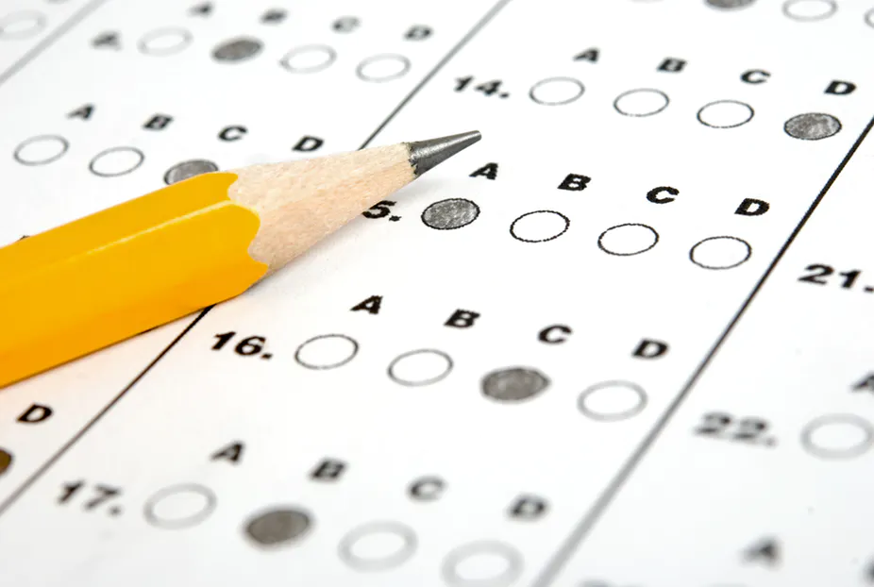

I chose this photo because I think it represents testing and in the passage I talk about Malala’s final exam.

**Music: Breath Me, by sia**

I chose this song because I think song she talks about having anxiety and she also says when you break down it’s ok. And I think that's what Malala was trying to say in this passage.

Dessa Shapiro

10/8/19

Loving Family

In the book I Am Malala the first part of the section I read not much had changed in Malala’s life since the last blog entry where that Tabilan had run out by the military. Malala’s life has continued to stay the same, not exactly good, but normal. She continued to go to school and hanging out with her friends. She also continued to stress about school and strive to be the best and to make a difference in her society. In the story, one day after school Malala was taking the bus home after school, her parents refused to let her walk because she was still getting threats from the Taliban. One day after school she got on the bus with her friends. While they were one the bus a group of Taliban soldiers stopped the truck and got in. They had rifles with them and said “Who is Malala? “

After that, one of the Taliban soldiers started shooting. They shot Malala in the head and they also shot a few of her friends that were sitting next to her. The bullet passed close to Malala’s eye and into her soldier. Thankfully there was no serious damage but the hospital did transfer Malala in a helicopter to a better hospital. Malala was unconscious and although the bullet did not directly hit her brain there was still some swelling in her brain from fragments of the bullets. The doctors ended up removing some of Malala’s skull to stop the swelling in her brain. After the swelling had gone down they reattached her skull. After a while, Malala’s condition started to worsen. Her father was very worried about her.

` Her father had a friend whose daughter had died when she was only 16 years old and when he called Malala’s father this is what he said “ My father cried.‘Tell me how can one live without daughters,’ he sobbed.”(pg. 260) I feel that I relate to this passage because there are a lot of things in this world that I love. And even though I have a very different lifestyle then Malala, but I know what it’s like to love what you don’t know what you would do if they are gone. I can empathise with Malala’s father because I can imagine what It would be like to lose one of my parents. When I was a first grader my father had to travel away for a month for his job. Back then I was still a little kid and I didnt think he would ever come back. I was so scared I cried almost every night he was gone. So, I can imagine what Malala’s father felt when he thought he had lost his beloved daughter forever. I also feel like in this passage the author brings the reader into the story and makes them feel what Malala’s father was feeling. I know that unless someone I love is in critical condition I will never be able to fully empathize with Malala’s father because I will never have the same experience. I also think that this part of the story resonates with me because my parents and I have always gotten along and I have a good relationship with them. I think that since I have a good relationship it would be that much harder to lose one of them, then for some other people.

**Song: foster the people, pumped up kicks**

I think this song relates to this passage because It talks about kids in a school shooting and Malala was in the same kind of scenario when she was shot on the bus.

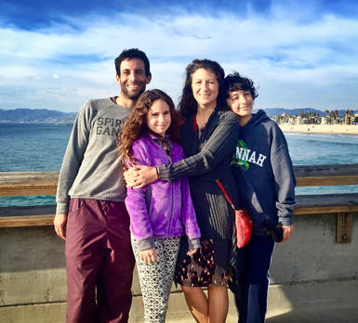

This is a picture of my family

Dessa Sahpiro

10/17/19

The Importance of Self

In the book *I Am Malala* by Malala Yousafzai, Malala(speaker and protagonist) was in a hospital In the UK after she had been shot in the head by the Taliban on her school bus. Malala had to be transferred to the hospital in the UK. She was transferred because in the other hospital her condition was worsening and the hospital was not clean and did not have good enough supplies to keep her alive. When she was leaving only Malala’s father was allowed to go with her. He knew that If he left the rest of their family will be in danger, so he did not go. Malala’s parents Ziauddin and Toor Pekai Yousafzai and her brothers Atal and Khushal had finally arrived in the UK to see Malala. She has been alone in the hospital for 10 days and she was just starting to get her face and hearing functions. She had to have surgery to repair the damaged nerve. And now she needed another surgery to repair her hearing. The surgeon had to put a cochlear implant( A small electronic device) inside Malala’s head so she could hear better.

“ We human beings don’t realize how great God is. He has given us an extraordinary brain and a sensitive loving heart. He has blessed us with two lips to talk and express our feelings, two eyes which see a world of colors and beauty, two feet which walk on the road of life, two hands to work for us, a nose which smells the beauty of fragrance, and two ears to hear the words of love. As I found with my ear, no one knows how much power they have in their each and every organ until they lose one.”( Pg. 300)

I relate to this passage because I have always been interested in how one's body works and throughout my life, I have always been a very active person and I injure myself. Sometimes it’s a sprain wrist and ankle and I can walk on my foot or use my hands to write or draw. These experiences allowed me to experience what I would be like to lose an important function and I bring light to how important these functions are. When I was around 10 years old I woke up one morning and my legs stopped working. I freaked out, later I realized that I had run a 5K the day before that and my muscles were very sore. I was also having growing pains so that could have contributed to my legs. But when I thought my legs didn't work I completely I couldn't think logically I could only process all the possibilities in my mind. What If I was never able to walk again, what if I was an outcast, what will my future be like. In Malala’s case, she had major injuries and more life-changing events lead up to her loss of hearing. There is a common saying that goes “you don't know what you have until it's gone” and I think that this saying connects to what Malala is saying because when losing a vital part of yourself, you realize that you should have respected what you were given and not disrespect yourself. Another reason I feel I connect to this passage is the way the author uses certain methods in her writing. In this passage, you can tell she used a parallel structure to exaggerate the impact of the words. She also used the listing to clarify and she gave examples after each statement which I felt helped me understand the impact of what she was saying.

## Song: Beautiful" by Christina Aguilera

I chose this song because it talks about how a person should respect themselves and acknowledge their beauty inside and out. It also relates to Malala because she had been self-conscious about her loss of abilities. But after a while, she learned that she should appreciate her life and what God has given her.

|  | I chose this picture because I thought it was a  Good abstract representation of color. And how color could apply to different parts of the body. Also how even though each color looks irrelevant if you remove or change one of the pencils it will change the whole rainbow. In other words you could say If you remove of change even one of your body parts your total function will never be the same. |
| --- | --- |